System Requirements Statement (SRS) –

Connecting2Doctor

Doc. Ref. :

Version : 0.4

Status : Drafted

Created by : Shubham , Atish , Akash , Neha , Harshal

Date : 26-02-2022

THIS DOCUMENT CONTAINS -- NUMBERED PAGES

* **1.** **Introduction 3**
* **2.** **Functional Requirements 4**
* 2.1 Patient Module 5
* 2.2 Doctor Module 11
* 2.3 Admin Module 17
* 2.4 Use Case Diagram 22
* **Introduction**

This document explains the system requirements and scope for developing Connecting2Doctor (online appointment) System.

Connecting2Doctor (online appointment) System could divide into the three main parts, Patient part, Doctor part and Admin part.

This document describes the system requirement of the Account part.

* **Functional Requirements**

The Account part of Connecting2Doctor (online appointment) System has three modules which are divided -- processes described as below.

|  |  |  |
| --- | --- | --- |
| **No** | **BRS requirement ID** | **Description** |
| **2.1** | **Patient Module** | |
| **2.1.1** | **F1** | **Registration Process** |
| **2.1.2** | **F2** | **Login Process** |
| **2.1.3** | **F3** | **Forgot Password Process** |
| **2.1.4** | **F4** | **Change Password Process** |
| **2.1.5** | **F5** | **Update Account Process** |
| **2.1.6** | **F6** | **Search Doctors** |
| **2.1.7** | **F7** | **Book Appointment** |
| **2.1.8** | **F8** | **Check Appointment Status** |
| **2.1.9** | **F9** | **Cancel Appointment** |
| **2.1.10** | **F10** | **View Appointment History** |
| **2.2** | **Doctor Module** | |
| **2.2.2** | **F11** | **Login Process** |
| **2.2.3** | **F12** | **Forgot Password Process** |
| **2.2.4** | **F13** | **Reset Password Process** |
| **2.2.5** | **F14** | **Active Appointment Process** |
| **2.2.6** | **F15** | **Create Slots Process** |
| **2.2.7** | **F16** | **Update Profile Process** |
| **2.2.8** | **F17** | **Cancel Appointment Process** |
| **2.2.9** | **F18** | **View Appointment History Process** |
| **2.2.10** | **F19** | **Show Todays Slots** |
| **2.3 Admin Module** | | |
| **2.3.1** | **F21** | **Login Process** |
| **2.3.2** | **F22** | **New Doctor Registration Process** |
| **2.3.3** | **F23** | **Patient List Process** |
| **2.3.4** | **F24** | **Doctor List Process** |
| **2.3.5** | **F25** | **Generate Report Process** |
| **2.3.6** | **F26** | **Manage Account Process** |

* **Patient Module**
* Patient is the user of system who can check doctor according to location, specialization.
* He is also able to book the appointment of available doctor.
* **Registration Process**
* Connecting2Doctor (online appointment) System compels to create the account for appointment booking. So, the system should provide the function which makes Patients create new account.
* When Patient creates new account, the function demands information described as below.
* Login information
* Contact Details
* Login information

The Login information consists of some items described as below

* UID Auto – Generated
* User Name
* Password
* First Name
* Last Name
* E-mail address
* Date of Birth
* Gender
* Blood Group
* All items are compulsory demanded.
* Email
* The Email should be unique. If the email correspond with not case-sensitive to other which is previously registered, the email should not be registered as an account.
* Password
* The Password has constraints which makes the Password consists of more than or equal 8 and less than or equal 16 characteristics including characters described as below.
* Numeric figure (at least one)
* Capital alphabet (A-Z) (at least one)
* Small alphabet (a-z) (at least one)
* Special character (#, $, %, &, etc.) (at least one)
* The password is masked by dummy characters. The re-entering Password is demanded.
* The password must be encrypted in Connecting2Doctor (online appointment) System.
* Contact Details
* The Contact Detail consists of some items described as below
* Area
* City
* State
* Contact Number
* All items are compulsory demanded.
* Address
* Address should be filled.
* The city and state should be selected from options.
* **Login Process**
* Connecting2Doctor (online appointment) System always compels user authentication for using web application.
* The user authentication demands Email and Password. The Email and the Password should be checked in two ways.
* First, The Email and the Password should be existed and correct.
* If The Email and the Password are not equal to what the user has registered, the user authentication cannot be provided.
* Second, Email should be available.
* The Administrator can decide whether the Email is available or suspended – Refer to the SRS of the Admin part.
* If patient is rejected, user authentication is not provided for system user.
* The “Patient Home Page” provides some items described as below.
* A trigger to logout
* A trigger to update Account
* A trigger to Change Password
* A trigger to Search Doctor
* A trigger to Book Appointment
* A trigger to Check Appointment Status
* A trigger to Cancel Appointment
* A trigger to View Appointment History
* **Forgot Password Process**
* When system user lost their Password, the recovery method should be provided by Connecting2Doctor system.

The recovery method is described as below.

* First, system user enters their Email for Connecting2Doctor System.
* Next, Connecting2Doctor System will sent OTP on the registered Email.
* Only when the Answer is correct, farmer get the new password by E-mail which also has been registered since when the Account was created.
* Only when OTP entered is match then user will able to change password.
* The new password is manually entered by patient.
* Of course, the new password should consist of more than or equal 8 and less than or equal 16 characteristics including at least a numeric figure, a capital alphabet, a small alphabet, and a special character.
* **Change Password Process**
* When patient wants to change their Password, the measure should be provided by Connecting2Doctor System.
* Therefore, system should provide the function which is available after getting the patient authentication.
* The function demands the current password and the new password.
* Of course, the new password should consist of more than or equal 8 and less than or equal 16 characteristics including at least a numeric figure, a capital alphabet, a small alphabet, and a special character.
* The current password and the new password are masked by using dummy characters.
* The new password is demanded to enter twice to avoid a typing error.
* Only when the current password is correct, patient could change their Password
* When the current password is changed into new password, system compels user authentication again.
* **Update Account Process**
* Connecting2Doctor System should provide the function which makes the account updated for patient.
* The patient can update the information as described below
* User information
* The User information

The updatable items as described below.

* Contact Number
* Area
* City
* State

All items are compulsory demanded, but updating is optional.

* **Search doctor**

After login user can search for a doctor based on

* Location
* Specialization

If user select location as a criterion, then the list of all doctors of respective location will get displayed.

If user will search for the doctor without selecting the criteria (location or specialization) or user select specialization as a criterion without selecting the location, then system will give the message that user must select location to get list of doctors.

* **Book appointment**

After getting the list of doctors according to location and specialization patient can select the particular doctor.

After selecting the doctor, all the slots will be shown to the patient. The slots before the login time of patient and slots which are already booked will not be shown to patient. Patient can see only the slots which are available for booking.

Patient can book appointment according to the available slots of the respective doctor.

* **Check Appointment Status**

After successfully booking an appointment, the patient can check appointment status.

* **Cancel Appointment**

After successfully booking an appointment if patient wants to cancel the appointment, *Cancel Appointment* option is provided to patient.

* **View Appointment History**

Patient could see the information of all the previous appointments according to date select for the history.

* **Doctor Module**

* **Login Process**
* Connecting2Doctor System always compels Doctor authentication before using itself except when a new account is successfully created.
* The user authentication demands Email and Password. The Email and the Password should be checked in two ways.
* First, The Email and the Password should be existed and correct.
* If The Email and the Password are not equal to what the user has registered, the user authentication cannot be provided.
* Second, Email should be available.
* The Administrator can decide whether the Email is available or suspended – Refer to the SRS of the Admin part.
* If user is rejected, user authentication is not provided for doctor.
* Only when the two checks are successfully completed, Doctor can be placed on respected page.
* The “Doctor Home Page” provides some items described as below.
* A trigger to logout
* A trigger to Reset Password
* A trigger to Active Appointments
* A trigger to Create slots
* A trigger to Update profile
* A trigger to Cancel Appointments
* A trigger to View Appointments History
* A trigger to Show todays slots
* **Forgot Password Process**
* When Doctor lost their Password, the recovery method should be provided by Connecting2Doctor system.

The recovery method is described as below.

* First, Doctor enters their Email for Connecting2Doctor System.
* Next Connecting2Doctor System demands the Answer which has been registered since when the Account was created.
* Only when the Answer is correct, Doctor get the new password by E-mail which also has been registered since when the Account was created.
* The new password is manually entered by doctor.
* Of course, the new password should consist of more than or equal 8 and less than or equal 16 characteristics including at least a numeric figure, a capital alphabet, a small alphabet, and a special character.
* If the Answer is not correct, otherwise, the correct Answer is demanded for doctor again.
* In that case, Of course, Doctor couldn’t get the new password.
* **Reset Password Process**
* Doctor can login using credentials given by the admin after successful registration.
* But for privacy doctor can reset password using Reset Password process.
* After reset password doctor will have to login by using new password for every time.
* The function demands the current password and the new password.
* Of course, the new password should consist of more than or equal 8 and less than or equal 16 characteristics including at least a numeric figure, a capital alphabet, a small alphabet, and a special character.
* The current password and the new password are masked by using dummy characters.
* The new password is demanded to enter twice to avoid a typing error.
* Only when the current password is correct, Doctor could change their Password.
* When the current password is changed into new password, Connecting2Doctor System compels Doctor authentication again.
* **Active Appointments Process**
* Doctor can able to see all the active appointment for a day.
* **Create Slots process**
* Doctor can create slots according to the availability.
* Doctor has to provide following details to create slots.
* Start Date
* End Date
* Start Time
* End Time
* Slot duration in minutes
* Break time
* Holidays
* All items are compulsory demanded.
* **Update Profile Process**
* Connecting2Doctor System should provide the function which makes the account updated for doctor.
* The information Doctor could update is described below.
* Contact Number
* Area
* City
* State
* Languages
* Consultation fee
* Qualification
* Specialization
* All items are compulsory demanded, but updating is optional.
* **Cancel Appointment**

• Doctor can cancel particular appointment if required.

* **View Appointment History**

• Doctor can view all appointments history.

* **View Todays Slots**

• Doctor can view all the slots which are available for booking appointments.

* **Admin Module**

**•** Administratorshould be responsible for following activities**.**

* **Login Process**
* Connecting2Doctor System always compels user authentication before using itself except when a new account is successfully created.
* The user authentication demands Email and Password. The Email and the Password should be checked as -
* The Email and the Password should be existed and correct.

If The Email and the Password are not equal to what the admin has registered, the admin authentication cannot be provided.

* The “Admin Home Page” provides some items described as below.
* A trigger to logout
* A trigger to add new doctor
* A trigger to view patient list
* A trigger to view doctor list
* A trigger to generate report
* A trigger to manage accounts (can enable or disable the account for the particular time or permanently)
* **Add Doctor (Registration)**

* Admin can create the new account for doctor by verifying all the information given by the doctor via email.
* When Patient creates new account, the function demands information described as below.
* If doctor wants to create account, he should sent all the following details to the admin by email:
* Details:

The details information consists of some items described as below

* First Name
* Last Name
* Email
* Area
* City
* State
* Date of Birth
* Gender
* Username
* Contact Number
* Languages known
* Qualification
* Specialization
* Fees
* All items are compulsory demanded.
* Admin will verify all the details and create the account for doctor.
* Admin will send first login credentials to doctor (email and password).

Password sent by admin is in the form firstname@123.

* **View Patient List**

• Admin should be able to see all the patient list according following criteria:

* All registered patients
* Location wise
* Doctor wise
* According to appointment date
* **View Doctor List**

• Admin should be able to see all the doctor list according following criteria:

* All registered doctors
* Location wise
* According to registration date of doctor
* **Generate Report**

• Admin should able to see all the records from any users.

• Admin will generate daily report of enrolment of doctors and patients.

• Admin will generate Monthly report of enrolment of doctors and patients.

• Admin will generate report of number of attended patients by doctor on daily and monthly basis.

• Admin will generate report of appointments taken by patients on daily and monthly basis.

* **Accounts Management**

• Admin should able to manage all the accounts (doctors and patients) with following activities,

1. Enable accounts

2. Disable accounts (Admin can disable account for temporary or permanently if the community guidelines are not followed by doctor or patient)

* **2.5 Use Case Diagram**

**Admin:**

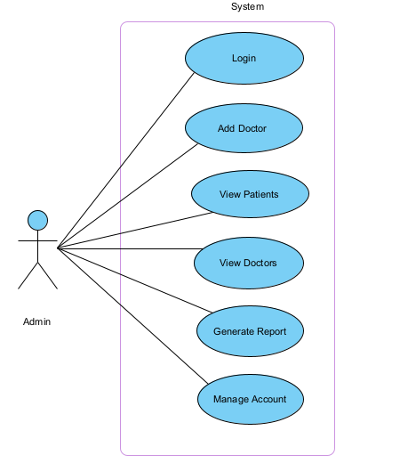

*Fig. Use case diagram for admin*

* In Admin use case diagram Admin is the Actor.
* Admin can handle following use cases:
* Login
* Add Doctor
* View Patient
* View Doctor
* Generate Report
* Manage Account

**Patient:**

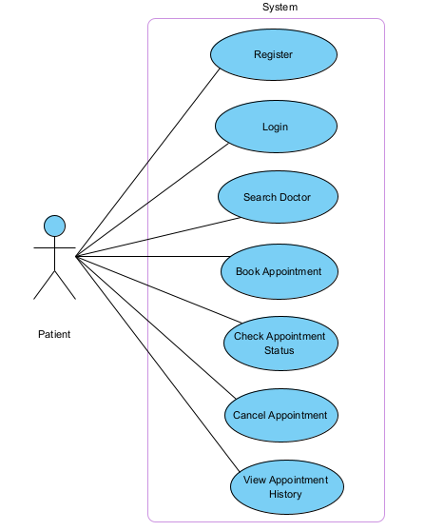

*Fig. Use case diagram for Patient*

* In Patient use case diagram Patient is the Actor.
* Patient can handle following use cases:
* Register
* Login
* Search Doctor
* Book Appointment
* Check Appointment Status
* Cancel Appointment
* View Appointment History

**Doctor:**

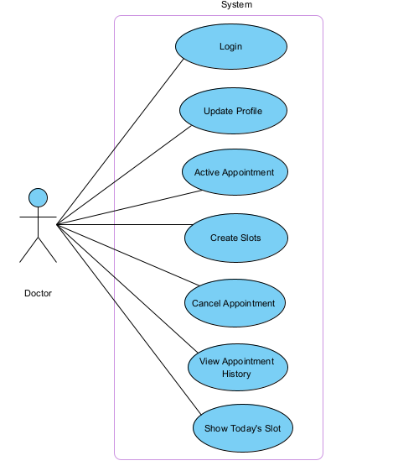

*Fig. Use case diagram for Doctor*

* In Doctor use case diagram Doctor is the Actor**.**
* Doctor can handle following use cases:
* Login
* Update Profile
* Active Appointment
* Create Slots
* Cancel Appointment
* View Appointment History
* Show Today's Slot